Once Banished, Never Silenced: ‘Judith Bernstein: HARD’ at the New Museum
By KEN JOHNSON
Published in the New York Times: ART REVIEW
December 20, 2012

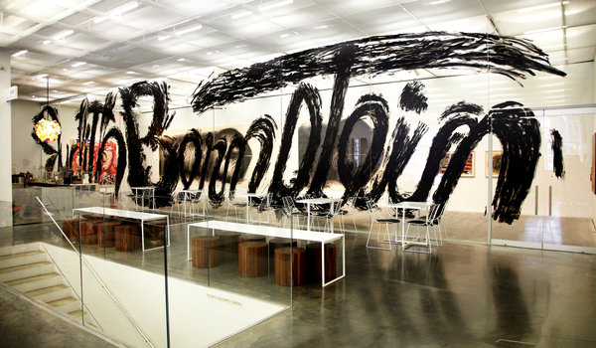
Photo: Jesse Untract-Oakner, New Museum

A re-creation of a Judith Bernstein mural from 1986 called “Signature Piece,” in her solo show at the New Museum.

Outstanding artworks in the Vietnam-era department of my personal mental museum include: James Rosenquist’s “F-111”; Peter Saul’s hallucinatory paintings of rape and carnage in Vietnam; Claes Oldenburg’s monumental sculpture of a giant lipstick standing vertically on military tank tracks; and Judith Bernstein’s mural-scale, charcoal drawings of enormous phallic screws. All of these have in common a more or less explicit metaphorical conflation of war and sexual violence.

As it happens, only one of those four artists has never had a solo museum exhibition until now: Ms. Bernstein, who has seven works from 1966 to 2012 in the New Museum’s lobby gallery.

Two of her gargantuan screw drawings are here, in “Judith Bernstein: HARD,” one from 1973 and one from 1975, and they still pack a powerful punch. In these bravura performances of draftsmanship on sheets of paper that are 12 ½-feet or 26-feet wide, the screws extend horizontally as if they were drilling tunnels through mountains. Rendered by countless sweeping strokes of charcoal, they appear at once wildly hairy and scarily purposeful. They have cylindrical shafts wrapped by spiral ridges and rounded heads with open slots at the ends. Of course, the conceptual punch line is the equation of screw and penis. These biomechanical monstrosities seem to be vibrating with testosterone-fueled fury, projecting a distinctly male state of mind perceived by many on the countercultural left then and now as responsible for all kinds of trouble in the world.

They are masterpieces of feminist protest. But vehemently accusatory though they are, there is a sense in which the artist participates in that phallic energy through imposing scale and the urgency of her mark-making. They are the works of a woman tapping into her own potential for bravery, rage and aggression.

Works from 1967 show that Ms. Bernstein was thinking about macho consciousness and foreign affairs much earlier. One of them represents the Stars and Stripes with erect penises crossed like swords in the starry corner. Words angrily written along the bottom advise a vulgar response to United States policy in Vietnam. A collage on canvas called “Fun Gun” has a cross-sectional diagram of the male reproductive system with real bullets (removed from their shells) forming a spiral in one testicle and shooting out through the horizontal penis like spermatozoa.

There is a remarkable leap of skill and ambition from these formative works to the big screw drawings. Another jump happens between the second of those drawings, “Horizontal Plus #3,” and the most recent piece, an 8-foot-by-8-foot painting called “Birth of the Universe #4 (Space, Time and Infinity)” (2012), a colorful, cartoon-Expressionist painting made with sensuous immediacy. Exactly what it represents is hard to say, but it seems to picture two bulbous, flaming creatures in a luminous, cosmic space. It projects a zany happiness that nothing else in the show would lead you to expect.

What happened between 1975 and 2012? There is one work in the show from those years: a re-creation of a 1986 mural called “Signature Piece.” Here Ms. Bernstein has scrawled in black paint her own name in floor-to-ceiling letters extending 66 feet across a glass wall. Partly it satirizes the art market’s cult of personality, which mainly embraces male artists. But there is a significance to this comically grandiose assertion of identity that the casual visitor might miss.

At a certain point in the early 1970s Ms. Bernstein’s screw drawings were appearing in all of the art magazines. I remember them well. They made a big splash and, you would have thought, augured good things to come by and for the artist. In 1974, however, something less salutary happened. She was invited to participate in a big all-women exhibition called “Focus: Women’s Work — American Art in 1974” at the now defunct Museum of the Philadelphia Civic Center. When the museum’s administrators saw the screw drawing she contributed — “Horizontal” (1973) — they deemed it “lacking in redeeming social value” and banished it from the show. During the next three decades Ms. Bernstein was unable to secure representation by a stable, influential gallery in New York, where she has lived since 1967.

It did not help either that around 1980 there emerged a new, conceptually based kind of feminist art by Barbara Kruger, Cindy Sherman and others that had more to do with wordplay and semiotic deconstruction than with highly charged image making. Ms. Bernstein’s kind of full-frontal visual assault went out of fashion. She became one of those artists about whom people say, “I wonder whatever happened to so-and-so?”
Then in 2004 the dealer Mitchell Algus, known for returning to visibility interesting but forgotten talents, put Ms. Bernstein in a group show at his gallery. Four years later he gave her a solo exhibition. Now, with laudatory reviews of the present show and profiles in multiple media outlets, she is, at 70, a hot commodity. So “Signature Piece,” first made when her name had faded from art-world memory, now has a newly inspirational layer of meaning. As it declared then, so it does now: “I’m still here, and I’m not giving up.”
“Judith Bernstein: HARD” runs through Jan. 20 at the New Museum, 235 Bowery, at Prince Street, Lower East Side; (212) 219-1222, newmuseum.org.

A version of this review appeared in print on December 21, 2012, on page C30 of the New York edition with the headline: Once Banished, Never Silenced.

