Judith Bernstein at Alex Zachary
Published in Mousse Magazine: AGENDA NEW YORK
December 7, 2010

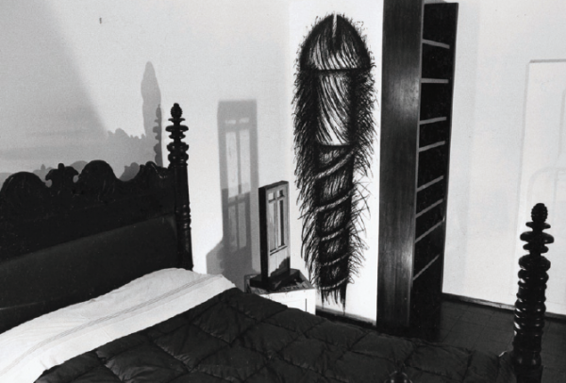

In 1977, Judith Bernstein made two installation works in the living room and the bedroom of William Copley’s townhouse near the Guggenheim Museum. As she explained “I kept thinking I was going to trash Bill’s place with his extensive Surrealist collection and get the results that Whistler had with his Peacock Room.” The domestic installation included iterations of her massive, iconic, phallus image. The baloneypony appeared iconoclastic and, yet, at the same time integrated with this luxury interior. Now she faces Alex Zachary, a decadent anomaly of a gallery that costumes a breathtaking garden-level, open-air-plan duplex apartment with eighties-modernist architectural embellishments. Bernstein has become most well known for her series of drywall screw-cum-penis drawings she started in 1969. Judith is a pre-nine-eleven feminist who has worked in New York for decades on issues of social subjugation. The drawings, alongside her more articulate collages, intend to empower the subjugated and, simultaneously, critique the dominant form. The massive hardware store dick drawings render the male exclusive object into an abstract form that now appears as a weapon that “draughtswomen” have equal right to bare. At the same time this theolo-totemic “third-leg” appears absurd as a form that holds sway in the distribution of power. Judith has plans for a massive charcoal drawing of her signature that will run across the townhouse gallery. The 1958 movie, “The Horse’ mouth” is projected in the large living-area downstairs.
Sir Alec Guinness plays a wild British artist who trashes a patron’s home and winds up having an exhibition at the British Museum. The motion picture should work less as a cinematic ready-made and more at the service of setting the attitudinal register in which to comprehend Judith’s tactile works in the exhibition.

Judith Bernstein at Alex Zachary
November 10 , 2010 — January 15, 2011
www.alexzachary.com

